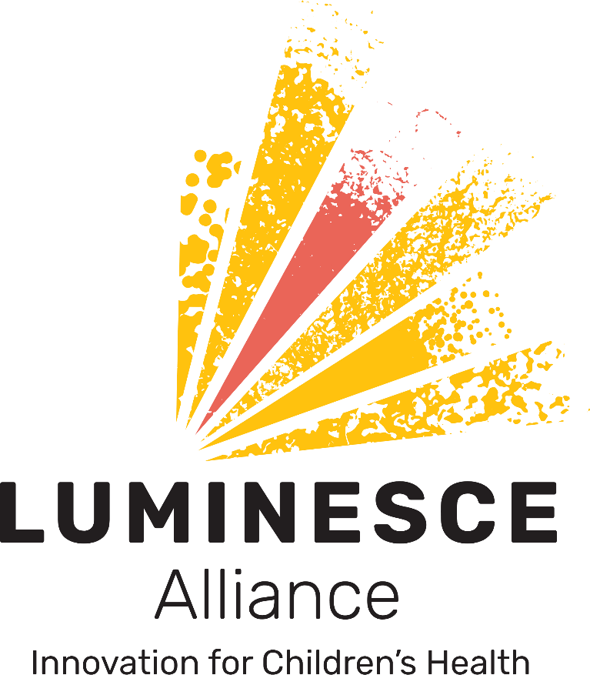

Medical Research Future Fund
Rapid Applied Research Translation Initiative Round 3
Expression of Interest

Application Form

February 2021

Contents
I. Background 3
II. Applicants Details 5
III. Project Overview 6
IV. Signatures 7
V. Submission Process 7

Background

The Australian Government has announced a substantial expansion of the Rapid Applied Research Translation (RART) Initiative Round 3, offering grants totalling $55 million over three years.

The RART Initiative, opening 4 March, specifically invests in research that encourages academic researchers and health service providers to collaborate to improve health care delivery, services and systems sustainability.

Luminesce Alliance will be managing an initial Expression of Interest (EoI) on behalf of our Partner organisations for this funding opportunity to help identify an application with the greatest potential for success.

The successful applicant will then be asked to complete the full MRFF RART Round 3 application due Thursday 6 May with the endorsement of Luminesce Alliance.

Luminesce Alliance will only consider applications for projects that focus on Paediatrics and in particular precision medicine/health.

Luminesce Alliance is eligible for the $11 million allocated to Stream 1: Organisations based in urban areas (any area according to the Monash Modified Model Locator), based on our geographic location as the lead organisation.

About the Initiative

The RART Initiative forms part of the Commonwealth MRRF, providing grants to support health and medical research, and innovation that will improve the health and wellbeing of Australians.

The purpose of the RART funding opportunity is to provide grants to support Australian medical research and medical innovation projects that:

- address a clearly defined gap in the implementation of best practice health care and health interventions to improve health outcomes;
- use existing knowledge to develop, test and implement new approaches for the translation of research findings into health care and health interventions that have potential for broader applicability; and
- involve all stakeholders relevant to the research and its translation in its conceptualisation, design and implementation, including health care consumers and providers.

The RART initiative focuses on the direct translation of research into practice, not research that may have the potential to be translated into practice sometime in the future. The level of available funding encourages large-scale projects involving multiple partners, so collaborations involving other states and territories should be considered

Eligibility

To be eligible the principal investigator must be employed by one of the Luminesce Alliance partners namely:
- The Children’s Cancer Institute
- The Children’s Medical Research Institute
- The University of Sydney
- The University of New South Wales Sydney

The University of Sydney, University of NSW and the MRIs within our partnership can each submit their own applications in addition to the Luminesce Alliance application. Sydney Children’s Hospital Network is NOT deemed as an eligible institution for this RART opportunity, but is an important partner organisation with the University of Sydney, University of NSW and our two MRIs.
Funding application steps

- Read the corresponding Luminesce Alliance Initial EoI Guidelines for the MRFF RART Initiative Round 3
- Read the MRFF RART Round 3 Grant Guidelines
- Complete this application form. Please use Arial 10 pt, and do not exceed word and/or page limits.
- Submit the application no later than 5 pm AEST on Wednesday 24 February 2021
- Late applications will not be accepted.

The Review Process

Luminesce Alliance will convene a review panel for the EoI applications. The review panel members will be at the discretion of Luminesce Alliance and will include nominated representatives from the Luminesce Alliance Partners. It may also include independent representatives outside of the Alliance. Nominated representatives will be asked to declare any conflict of interest prior to any discussion of any application. This includes being a named investigator on the application. They will be excused from any deliberation of that application should they declare a conflict of interest.
- Individual review panellist will be asked to review and rank the application based on a set of criteria as outlined in the accompanying Luminesce Alliance EoI Guidelines for the MRFF RART Initiative Round 3.
- The scores and review of the panel will be collated, and a final score will be tallied.
- The final determination will be based on the final score.
- Luminesce Alliance will liaise with the successful applicant about progressing to the full application process for the MRFF RART Round 3 application which opens Thursday 4 March and closes Thursday 6 May.
- Unsuccessful applicants will not receive specific information about the ranking, content or quality of the application as assessed by the panel.

Important Dates

Wednesday 10 February 5pm AEST | EoI applications open via the Luminesce Alliance website.  www.luminesce.org.au
Wednesday 24 February 2021 5pm AEST | EoI applications close.  Eligible and complete EoI applications must be submitted by 5pm AEST on the closing date.  Late applications will not be accepted.
Tuesday 2 March | Outcomes of EoI applications notified to CIAs.  Luminesce Alliance will liaise with the successful applicant about progressing to the full application process for the MRFF RART Round 3 application which opens Thursday 4 March and closes Thursday 6 May.
Thursday 4 March | MRFF RART Round 3 opens (full application forms made available).
Thursday 6 May | Deadline for full application submission to MRFF

Applicants Details
Chief Investigator | Name:  Job Title:  Qualification:  Telephone:  Mobile:  Email:  Employer:
Institutional Affiliation | ☐ Children’s Medical Research Institute  ☐ Children’s Cancer Institute  ☐ University of New South Wales  ☐ University of Sydney
Investigator B | Name:  Job Title:  Qualification:  Telephone:  Email:  Employer:
Investigator C  (up to 8) | Name:  Job Title:  Qualification:  Telephone:  Email:  Employer:
Name of partner organisations  Partner organisations are involved in the project but not represented by one or more chief Investigators | Organisation 1:  Organisation 2:  Organisation 3:  Organisation 4:  (add further organisations as required)
Name of participating hospitals or health services where the project will be conducted
In which part(s) of Australia are the participating hospitals or health services located? (select all that apply) | ☐Sydney only  ☐Parts of NSW other than Sydney  ☐ACT  ☐Queensland  ☐Victoria  ☐Tasmania  ☐South Australia  ☐Western Australia  ☐Northern Territory

Project Overview
- Project title

- Please provide an Executive Summary outlining: (maximum 2 pages not inclusive of references):
- how the project meets the MRFF RART purpose;
- overview of the project methodology;
- key activities, intended outcome(s) and likely impact; and,
- why the application is likely to succeed.

- Indicative 5 year total funding to be requested from MRFF RART (maximum $10 M)
(Note: A detailed budget will be required for the successful application)

- Will funding be available from other sources for this project?
Specify source and approximate amount

- Justification for funding request:
Please provide a brief rationale for the scale of the problem being addressed, the proposed expenditure for the project, the immediate impact on participating health services, the sustainability of the impacts, and the potential for wider adoption by other health services beyond the life of this project (max 500 words).

- Indicative project duration
Project start date not before 1 July 2021; maximum project length 5 years

Estimated project start date:

Estimated project end date: ___________

- Is the project being considered by another institution/organisation as part of the MRFF RART Round 3 funding opportunity?
If yes, please state the name(s) of the institution/organisation.

Signatures

Chief Investigator | I, as the Chief Investigator, have read and understood the eligibility criteria, the EoI funding application process and will be able to accept the terms and conditions of the MRFF RART funding grant should the application be successful.  Name:  Department/Institution:  Email:  Signature:  Date:

Submission Process

Please prepare the following for submission:

- A Word version of the application form
- A PDF version of the application form

Please electronically submit both documents to:

info@luminesce.org.au

Please use the Email Heading: Expression of Interest Application: MRFF RART Initiatives

Completed applications are to be submitted by no later than 5 pm AEST on Wednesday 24 February 2021

